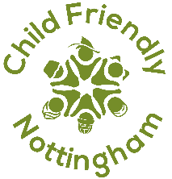
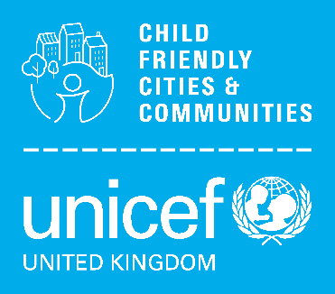
Reflective Practice: Story of Change
Impact Study Development Template
Prompt Questions*:
- What happened?
- Who did it involve?
- For how long did it run/is it ongoing?
- What changed in terms of relationships and ways of working?
- What changed in terms of child & youth engagement / experiences of how place/service feels?
- What changed in how adult stakeholders spoke and acted in terms of a child rights-based approach?
- What was the impact of the work for children & young people?
- How do you know it was successful?
- Is it sustainable/how will you keep it moving forwards?
- What did you learn?
- What did you learn about the conditions needed for this kind of change?
- What would you do differently next time?
*please use these as a guide, not all have to be answered


Proposed Impact Study:

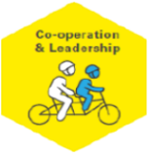
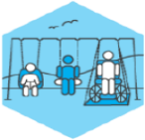

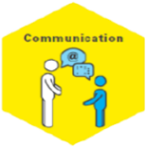
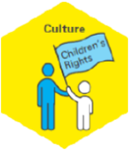
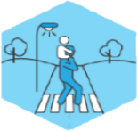

Nottingham’s CFC Badge(s)

Equal and Included
Education and
Learning
Safe and Secure
Healthy
- Safe and Secure
- Healthy
- Education and Learning
- Equal and Included (Golden Thread)
- Culture
- Co-operation and Leadership
- Communication
Outcome
(from Nottingham’s Action Plan)
How are the voices and experiences of seldom-heard (under representative) children and young people shaping this impact study?
Consider the 7 principles of a Child Rights-Based Approach (details below). Reflect on each one individually in relation to your chosen impact study. How does the example you’ve chosen demonstrate the principles in practice?
Dignity

Participation

Life, Survival & Development

Non-discrimination

Transparency & Accountability

Best Interests
Interdependence & Indivisibility

Please email completed evidence form to child.friendly@nottinghamcity.gov.uk

